**[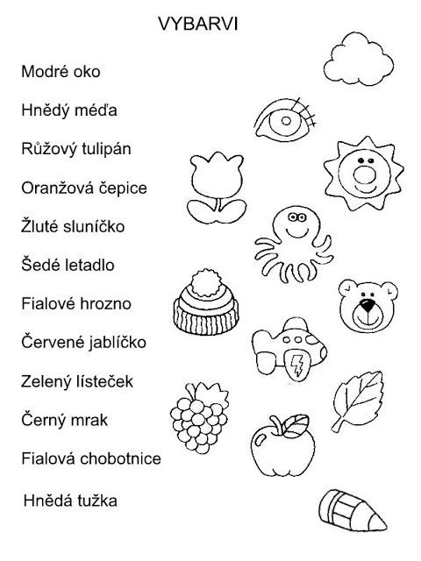](https://ms-klicek-hranice-2015-16.webnode.cz/news/procvicujeme-matematicke-predstavy/)**