Hello everybody!
Thanks for sending me your homeworks (Canada text part 11- 15 tasks and the Project).
Those of you who have not send your work yet, please do it 19.4. the latest!

Now something different for the week after Easter holidays:
1. Easter crossword
2. Sound effects in comics
For help go to: www.comicbookfx.com-sound effect database or www.translate.google.com Send your works to mrepikova@seznam.cz, 19.4. the latest!
Soubory prosím pojmenujte následovně: "Příjmení-crossword" a "Příjmení- comic sounds".

Přeji všem hodně zdaru :o) Have fun!

1. 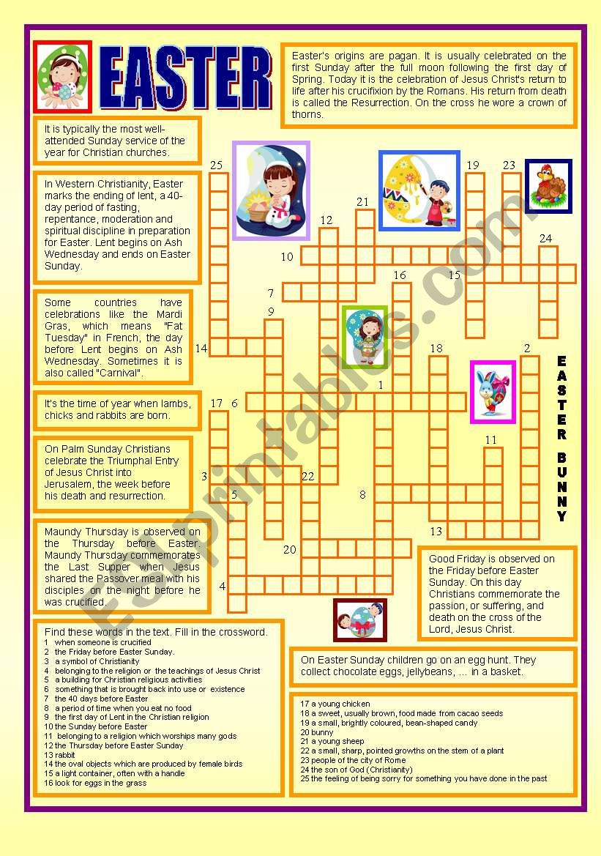
2. 