7D Po 18.5 - Pá 22.5. 2020

Hello, MY DEAR STUDENTS!
Another work week has come and I owe you new tasks: it is going to be something different than the standard worksheets.I have decided to devote next few weeks to the topic of COMICs- language of comics, basic terminology ( sound effect words), how to proceed to finally create a decent comic strip or even a gothic novel..

Task for this week:
1. Pracovní list- sound effects- onomatopoeic words used in comics ( no need to send it, just try to guess and than check with the translator yourself....)
2. Start to practice writing speech texts into talk and thought bubbles of various characters.
I have downloaded for you sort of a work book written by a famous comic author William Zimmerman:
https://www.makebeliefscomix.com/wp-content/uploads/2019/06/YLICOMICS-final2.pdf
This book is presented in the form of an interactive digital journal. It allows you to directly type your thoughts into the designated areas on each of the book’s pages. When you finish typing, simply save the document until the next time. If you like, you can also print out the pages and draw in the blank areas.
2a. read the introduction part (page 1 - 6)
2b. then complete speech bubbles in task 1 - 10. I recommend to formulate your ideas in Czech first and then translate it into English.

To help you with the text use following list of basic Sound effects terminology or you can go to: www.comicbookfx.com-sound effect database or www.translate.google.com ( this translator will help you to understand this letter too...!)

Reminder: to those who have not shown any activity yet ( no HW sent to me during Covid period ):
I recommend you do it as soon as possible- we are slowly running out of time!
Please call me rather than write me in case of any questions either regarding the previous home works or the new comic topic. I will be pleased to hear from you so don´t be shy!

I hope you will enjoy this new activity and I am looking forward to see your contributions. Regards, pí.uč.
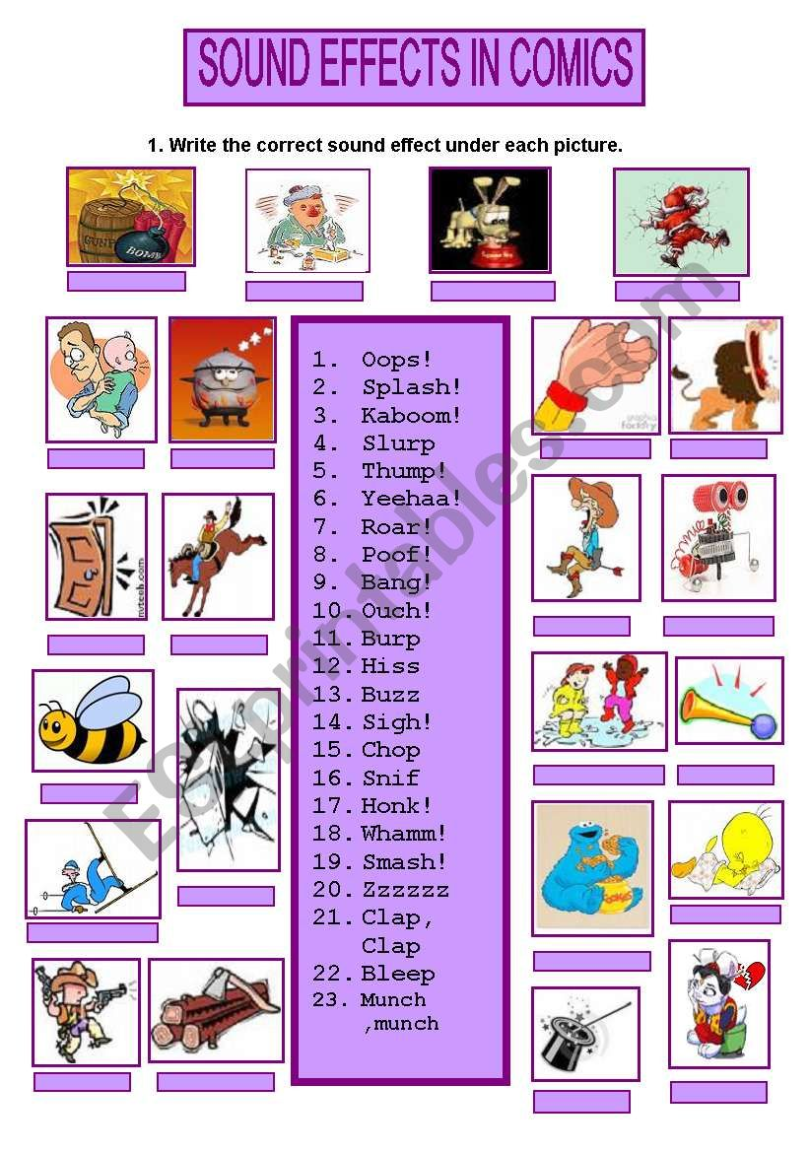

Onomatopoeic Sound Effects - basic terminology
crackle - a sound made up of a rapid succession of slight cracking sounds. Also look up: sizzle, fizz, hiss, crack, snap, fuse, fuze, burn, fire
crash - a sudden loud noise as of something breaking or hitting another object. Also look up: bang, smash, crack, bump, thud, clatter, clunk, clang, hit
bodyfall - a sound made by a body falling onto a hard surface. Also look up: body hit, land
boing - the noise representing the sound of a compressed spring suddenly released. Also look up: bounce, bouncing, bonk, jaw harp
boom - a loud, deep, resonant sound. Also look up: explosion, slam, crash, drum, taiko, rumble
buzz - a humming or murmuring sound made by or similar to that made by an insect. Also look up: hum, drone, insect, neon, fluorescent
chomp - munch or chew vigorously and noisily. Also look up: munch, crunch, chew, bite
click - a short, sharp sound as of a switch being operated or of two hard objects coming quickly into contact. Also look up: clack, snap, pop, tick, clink, switch, button
creak - a harsh scraping or squeaking sound. Also look up: squeak, grate
flutter - the sound of flying unsteadily or hovering by flapping the wings quickly and lightly. Also look up: beat, flap, quiver, wing
glug - the sound of drinking or pouring (liquid) with a hollow gurgling sound. Also look up: pour, drain
groan - a low creaking or moaning sound when pressure or weight is applied to an object OR an inarticulate sound in response to pain or despair. Also look up: creak, squeak; moan, cry, whimper
honk - the cry of a wild goose. Also look up: gander, goose
ahoogah - the sound of a particular type of horn. Also look up: model a, model t, antique horn, bulb horn
jingle - a light ringing sound such as that made by metal objects being shaken together. Also look up: clink, chink, tinkle, jangle, chime, sleigh bells
neigh - a characteristic high-pitched sound uttered by a horse. Also look up: whinny, bray, knicker
poof - used to convey the suddenness with which someone or something disappears. Also look up: puff
pop - a light explosive sound. Also look up: bubble, cork, jug, thunk
puff - a short, explosive burst of breath or wind. Also look up: poof, gust, blast, waft, breeze, breath
rattle - a rapid succession of short, sharp, hard sounds. Also look up: clatter, clank, clink, clang
ribbit - the characteristic croaking sound of a frog. Also look up: frog, toad, croak
quack - the characteristic harsh sound made by a duck. Also look up: duck, mallard
rustle - a soft, muffled crackling sound like that made by the movement of dry leaves, paper, cloth, or similar material. Also look up: swish, whisper, movement, mvmt
rumble - a continuous deep, resonant sound. Also look up: boom, sub, earthquake
scream - a long, loud, piercing cry expressing extreme emotion or pain. Also look up: shriek, screech, yell, howl, shout, bellow, bawl, cry, yelp, squeal, wail, squawk
screech - a loud, harsh, piercing cry. Also look up: shriek, scream, squeal
skid - an act of skidding or sliding. Also look up: slide, drag
slurp - a loud sucking sound made while eating or drinking. Also look up: suck, drink, straw, lick
splash - a sound made by something striking or falling into liquid. Also look up: spatter, bespatter, splatter, bodyfall water
splat - a sound made by a wet object hitting a hard surface. Also look up: squish
splatter - splash with a sticky or viscous liquid. Also look up: splash, squish, splat, spray
squawk - a loud, harsh or discordant noise made by a bird or a person. Also look up: screech, squeal, shriek, scream, croak, crow, caw, cluck, cackle, hoot, cry, call
squeak - a short, high-pitched sound or cry. Also look up: peep, cheep, pipe, squeal, tweet, yelp, whimper, creak
squish - a soft squelching sound. Also look up: splat, splatter
swish - a light sound of an object moving through the air. Also look up: whoosh, swoosh
swoosh - the sound produced by a sudden rush of air. Also look up: swish, whoosh
thunk - the sound of a cork being pull out of or placed into a bottle or jug. Also look up: pop, cork, jug
twang - a strong ringing sound such as that made by the plucked string of a musical instrument, a released bowstring, or a ruler held steady on one end and plucked from the other. Also look up: ruler twang, boing twang, ripple, pluck, violin, guitar
whip crack - the loud and sudden sound of a whip moving faster than the speed of sound, creating a small sonic boom. Also look up: bull whip, whip, swish, whoosh, swoosh
whoosh - a heavy sound of an object moving through the air. Also look up: swish, swoosh
woof - the sound made by a barking dog. Also look up: bark, howl, yelp, whimper, dog
yelp - a short sharp cry, especially of pain or alarm. Also look up: squeal, shriek, howl, yowl, yell, cry, shout
zap - a sudden burst of energy or sound. Also look up: laser, beam, synth, sci-fi

